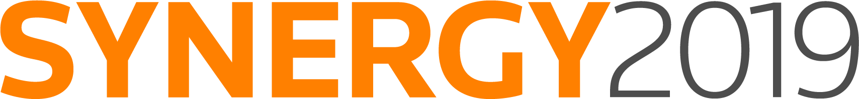

To:

From:

Re: SYNERGY 2019

Dear <Insert manager name here>,

I’m writing to ask for approval to attend SYNERGY, the annual Thomson Reuters ONESOURCE™ users’ conference, from November 10–13 in Denver, CO.

Attending the SYNERGY conference will help me learn more about our ONESOURCE products and how we can use them more effectively. It will also provide opportunities to discuss best practices and compare workflow processes with other tax professionals.

With hundreds of sessions to choose from, the conference will provide the majority of my required CPE credits for the year. These sessions include updates on the latest trends and technology so I can learn about the best ways to help our tax department operate more efficiently.

The full list of available sessions will be published this summer, but specifically I would like to attend sessions at the conference that are on topics such as:

<Insert topics that appeal to you below. These are just examples.>
- Tax Provision
- Transfer Pricing
- Indirect Tax
- Trust Tax

Here’s an approximate breakdown of the expected conference costs:

Airfare: $ XXX
Ground transportation: $ XXX
Hotel: (3 nights at $279/night) $ 837 (plus resort fee, plus tax)
Meals: (during travel) $ 150 (estimated)
Registration Fee (includes six meals): $ 1,975–$2,850
(Dependent on date of registration)
*Note: If I register before August 31, I get the lowest possible conference registration rate.

Total: $ X,XXX

I’m currently working on ways to reduce expenses, including taking advantage of the early-bird discount, hotel discounts, ride sharing and meals with vendors. I’ll submit a post-conference report that will include an executive summary, major takeaways and tips. I can also share relevant information with key staff members throughout the company.

Thank you for your consideration.

<insert your name>

